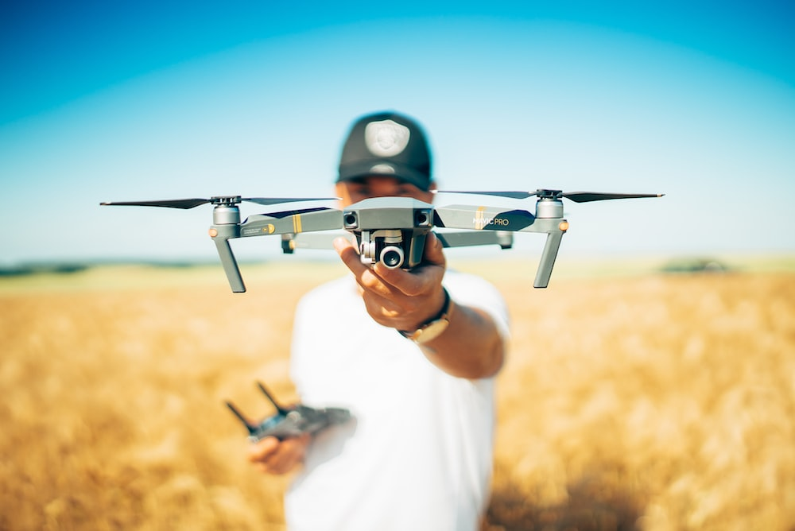PATH PLANNING FOR DRONES FLYING BEYOND VISUAL LINE OF SIGHT

INTERNSHIP REPORT

Submitted By

SOUMIK DAS

School of Engineering and Technology (SOET)

Program: B.Tech (CSE)

Department: Computer Science and Engineering

Adamas University, Kolkata, India

Under the Guidance of

Dr. Punyasha Chatterjee

Associate Professor and Director

School of Mobile Computing and Communication

Jadavpur University, Kolkata, India

3rd July –31st August, 2023

**Acknowledgment**

On the submission of my internship report on “Path Planning for Drones flying Beyond Visual Line of Sight”, I wish to express gratitude to the School of Mobile Computing and Communication of Jadavpur University for sanctioning an internship under which my work has been completed.

I would like to convey my sincere gratitude to Dr. Punyasha Chatterjee, Associate Professor and Director, School of Mobile Computing and Communication, Jadavpur University for her valuable suggestions and guidance throughout this project. I am really grateful to her, for her constant support which helped me a lot to complete my project.

Thank You

Regards,

__________________

Soumik Das

B.Tech (CSE)

School of Engineering and Technology (SOET)

Adamas University, Kolkata, India

**Abstract**

Unmanned Aerial Vehicles (UAVs), commonly known as drones, have demonstrated substantial potential across various industries. One of the most promising applications is Beyond Visual Line of Sight (BVLOS) operations, where drones can perform tasks beyond the operator's direct line of sight. However, BVLOS operations introduce complex challenges related to safety and risk management. This project aims to address these challenges by developing a comprehensive framework for risk assessment and path planning for BVLOS drone missions

The primary objective of this project is to enhance the safety and reliability of BVLOS drone operations through systematic risk evaluation and efficient path planning strategies. The proposed framework incorporates advanced sensor technologies, real-time data analysis, and machine learning algorithms to assess potential hazards in the operational environment. By considering factors such as weather conditions, airspace congestion, terrain variations, and regulatory constraints, the system can dynamically identify and mitigate risks.

The path planning component of the framework leverages predictive modeling and optimization techniques to chart safe and efficient routes for BVLOS drones. By integrating real-time data feeds and historical flight information, the system can adapt to dynamic changes in the environment and optimize routes to avoid high-risk areas. This not only ensures the safety of the drone and other airspace users but also maximizes the efficiency of the mission.

**Table of Contents**

**Acknowledgement ----------------------------------------------------------------------------------------------------- 2**

**Abstract ----------------------------------------------------------------------------------------------------------------- 3**

**Chapter 1 ------------------------------------------------------------------------------------------------------------- 5-9**

1. Introduction ---------------------------------------------------------------------------------------------------------- 5

1.1 Different categories of drone operations -------------------------------------------------------------- 6

1.2 Operations performed by BVLOS Flights -------------------------------------------------------------7

1.3 Challenges of BVLOS Operations ---------------------------------------------------------------------8

1.4 Risk Associated with BVLOS Flights -----------------------------------------------------------------9

**Chapter 2 ---------------------------------------------------------------------------------------------------------- 10-11**

2. Risk Assessment ----------------------------------------------------------------------------------------------------10

2.1 Risk Map Generation -----------------------------------------------------------------------------------10

2.2 No fly zone-----------------------------------------------------------------------------------------------10

2.3 Sheltering Factor ----------------------------------------------------------------------------------------11

2.4 Probability of crash of drone ---------------------------------------------------------------------------11

2.5 Probability of impacting a person ---------------------------------------------------------------------11

2.6 Probability of fatality ----------------------------------------------------------------------------------- 11

**Chapter 3 ---------------------------------------------------------------------------------------------------------- 12-19**

3. Implementation ----------------------------------------------------------------------------------------------------- 12

3.1 Urban Region-------------------------------------------------------------------------------------------- 13

3.2 Sub Urban Region -------------------------------------------------------------------------------------- 16

3.3 Rural Region--------------------------------------------------------------------------------------------- 19

**Chapter 4 ---------------------------------------------------------------------------------------------------------- 21-26**

4. Result ---------------------------------------------------------------------------------------------------------------- 21

4.1 Graphical Analysis of Urban Region ---------------------------------------------------------------- 21

4.2 Graphical Analysis of Sub Urban Region ------------------------------------------------------------23

4.3 Graphical Analysis of Rural Region ------------------------------------------------------------------24

4.4 Graphical Analysis of different regions at same altitude ------------------------------------------ 25

**Chapter 5 -------------------------------------------------------------------------------------------------------------- 27**

5.1 Conclusion -----------------------------------------------------------------------------------------------27

5.2 Future Work ----------------------------------------------------------------------------------------------27

**References -------------------------------------------------------------------------------------------------------------28**

**Appendix -------------------------------------------------------------------------------------------------------------- 29**

**Chapter 1**

**1. Introduction**

Unmanned Aerial Vehicles (UAVs), commonly referred to as drones, have become ubiquitous tools with applications spanning from aerial photography to disaster relief. As the capabilities of drones continue to evolve, their potential to autonomously navigate complex environments becomes increasingly evident. One of the pivotal aspects in achieving this autonomy is path planning – the process of determining the optimal route a drone should follow to reach its destination while avoiding obstacles and adhering to predefined constraints.

Path planning for drones is a multidisciplinary endeavor that intersects robotics, artificial intelligence, and aerospace engineering. Unlike traditional modes of navigation, where a human operator directly controls the vehicle, autonomous path planning empowers drones to make decisions on-the-fly based on their surroundings and mission objectives. This capability is especially crucial in scenarios where drones need to navigate intricate terrains, avoid collisions, and optimize their trajectories for efficiency.

In its essence, path planning seeks to strike a balance between multiple conflicting objectives. The drone must navigate efficiently, conserve energy, avoid obstacles, and adhere to regulations and safety guidelines. Achieving these goals demands the integration of various technologies, including sensor systems for environmental perception, algorithms for route optimization, and real-time decision-making mechanisms.

The path planning process involves several key elements:

1. **Environment Perception:** Drones rely on sensors such as cameras, lidar, radar, and GPS to perceive their environment. These sensors provide essential data about obstacles, terrain, weather conditions, and the positions of other aircraft or objects.
2. **Map Generation:** Based on the sensory data, drones construct a representation of their environment. This map helps identify obstacles and plan paths around them.
3. **Algorithmic Techniques:** Advanced algorithms play a pivotal role in generating feasible and efficient paths. These algorithms balance factors such as distance, energy consumption, safety, and mission objectives.
4. **Real-time Adaptation:** Dynamic environments require real-time adaptation. Drones must continually update their path plans based on changing conditions, new obstacles, and emerging risks.
5. **Collision Avoidance:** A core element of path planning is collision avoidance. Drones need to anticipate potential collisions with obstacles or other vehicles and modify their paths accordingly.
6. **Trajectory Optimization:** Beyond simple route planning, trajectory optimization involves planning the drone's movement in three dimensions, considering factors like altitude and speed.

As drones increasingly integrate into our daily lives – from package delivery to search and rescue missions – the role of path planning becomes paramount. This paper explores the intricacies of drone path planning, including challenges, methodologies, and technological advancements. By understanding the complexities involved in autonomously charting safe and efficient courses, stakeholders can develop drones that navigate seamlessly through complex environments, expanding their potential applications and impact.

**1.1 Different Categories of Drone Operations**

VLOS, EVLOS, and BVLOS are terms used to describe different categories of drone operations based on the visual line of sight between the operator and the drone. Here's what each term stands for:

1. **VLOS (Visual Line of Sight):** VLOS refers to drone operations where the operator must maintain direct visual contact with the drone at all times during its flight. This means that the operator should be able to see the drone with unaided vision, ensuring they can monitor its movement and surroundings. VLOS operations are typically considered the simplest and safest form of drone operation and are often subject to less stringent regulatory requirements.

**Uses:** Aerial Photography and Videography, Recreational Flying, Inspections

1. **EVLOS (Extended Visual Line of Sight):** EVLOS operations involve flying a drone beyond the operator's direct line of sight but within the operator's visual line of sight aided by binoculars, telescopes, or other vision-enhancing tools. While the drone may be at a greater distance from the operator, the operator still maintains visual contact with the aircraft, albeit with the assistance of optical aids. EVLOS allows for greater operational range and flexibility compared to VLOS.

**Uses:** Agricultural Surveys, Industrial Inspections, Search and Rescue

1. **BVLOS (Beyond Visual Line of Sight):** BVLOS operations involve flying a drone beyond the operator's direct line of sight, without the operator being able to see the drone with unaided vision. BVLOS operations typically require sophisticated technology, including advanced sensors, communication systems, and automation, to ensure safe and reliable flight. These operations have the potential to revolutionize industries by allowing drones to cover larger distances and access remote areas, but they also present complex challenges in terms of navigation, collision avoidance, and regulatory compliance.

**Uses:** Infrastructure Inspections, Delivery Services, Environmental Monitoring.

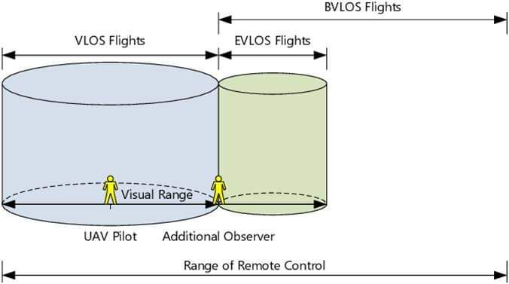

**Figure 1.1: Range of VLOS, EVLOS and BVLOS Flights**

In this project the main focus is on the BVLOS flights. BVLOS (Beyond Visual Line of Sight) refers to operations where the drone is flown beyond the visual line of sight of the operator. In BVLOS operations, the operator does not have direct visual contact with the drone and relies on technologies such as cameras, sensors, and data links for situational awareness and control. BVLOS operations typically involve more complex operations, longer distances, and may require special permissions or waivers from aviation authorities due to safety and regulatory concerns.

**1.2 Operations Performed by BVLOS Flights**

Here are some common operations that can be performed using BVLOS drone operations:

* **Infrastructure Inspection:** BVLOS operations allow drones to inspect extensive infrastructure networks, such as power lines, pipelines, and railways. Drones equipped with high-resolution cameras and sensors can assess the condition of these assets and identify potential issues, such as corrosion, damage, or wear and tear.
* **Agricultural Monitoring:** BVLOS-capable drones can monitor large agricultural fields, gather data on crop health, identify pest or disease outbreaks, and assess irrigation needs. This information helps farmers optimize crop yields and resource utilization.
* **Search and Rescue:** In emergency situations, BVLOS drones can cover vast areas more quickly than ground teams. They can locate missing persons, assess disaster-stricken areas, and provide real-time data to aid search and rescue efforts.
* **Environmental Surveys:** BVLOS drones are used for environmental monitoring, including tracking wildlife populations, surveying ecosystems, and assessing deforestation. They can capture data from remote or inaccessible areas that might otherwise be challenging to reach.
* **Remote Sensing and Mapping:** Drones can perform aerial surveys for mapping purposes, creating topographical maps, 3D models, and accurate geospatial data. BVLOS operations enhance mapping capabilities, especially in expansive or hard-to-reach regions.
* **Delivery Services:** BVLOS drones have the potential to revolutionize the delivery industry by transporting goods to remote areas or delivering essential supplies during emergencies. They offer quicker and more efficient delivery options, particularly for urgent situations.
* **Pipeline and Utility Inspections:** Drones can inspect miles of pipelines, power lines, and other utilities for leaks, damage, or maintenance needs. BVLOS operations make it possible to monitor vast networks more effectively.
* **Wildlife Conservation:** BVLOS drones aid in monitoring wildlife populations, tracking migration patterns, and surveying habitats. They can provide valuable data for conservation efforts and protection of endangered species.
* **Precision Agriculture:** BVLOS drones equipped with various sensors can create detailed maps of agricultural fields, analyze soil conditions, monitor crop growth, and apply targeted interventions such as fertilizers or pesticides.
* **Traffic and Transportation Monitoring:** BVLOS drones can monitor traffic flow, congestion, and road conditions in urban areas, helping city planners make informed decisions to improve traffic management.
* **Environmental Response:** During natural disasters or environmental incidents, BVLOS drones can assess the extent of damage, monitor environmental impact, and assist in planning recovery efforts.

**1.3 Challenges of BVLOS operations**

Beyond Visual Line of Sight (BVLOS) drone operations offer great potential for various industries, but they also come with a range of challenges that need to be addressed for safe and successful implementation. Some of the key challenges of BVLOS operations include:

* **Regulatory Frameworks:** BVLOS operations involve flying drones in airspace shared with manned aircraft. Developing appropriate regulations that ensure the safety of both drones and other airspace users while allowing for BVLOS operations can be complex. Regulatory bodies need to strike a balance between innovation and safety.
* **Air Traffic Management:** Integrating BVLOS drones into existing air traffic management systems is challenging. Ensuring that drones can operate safely in shared airspace requires sophisticated communication and collision avoidance systems to prevent mid-air collisions with other aircraft.
* **Communication and Connectivity:** BVLOS operations require continuous communication between the drone and the operator. Maintaining a reliable and robust communication link, especially in remote or congested areas, can be difficult and requires advanced communication technologies.
* **Collision Avoidance:** Ensuring that BVLOS drones can detect and avoid obstacles and other aircraft in real-time is critical. Developing accurate collision avoidance systems that work effectively in various environmental conditions is a significant technological challenge.
* **Sensor Reliability:** BVLOS drones rely heavily on sensors such as GPS, and radar to navigate autonomously. Ensuring the reliability of these sensors in various weather conditions and environments is essential to prevent accidents.
* **Weather Conditions:** BVLOS operations can be affected by changing weather conditions. Wind, rain, fog, and other weather factors can impact drone performance and visibility, affecting safe navigation and communication.
* **Technological Limitations:** Current drone technology may not fully meet the requirements of BVLOS operations. Developing drones with longer endurance, improved battery life, and more advanced sensor capabilities is necessary to ensure safe and efficient BVLOS operations.
* **Data Processing and Analysis:** BVLOS operations generate a significant amount of data, including sensor data, real-time imagery, and navigational information. Efficiently processing and analyzing this data to make informed decisions in real-time is a challenge.
* **Legal and Privacy Concerns:** BVLOS operations may raise legal and privacy concerns related to data collection, surveillance, and potential intrusions. Ensuring that BVLOS operations adhere to privacy laws and respect individuals' rights is crucial.
* **Operator Training and Skills:** Operating drones in BVLOS scenarios requires specialized training and skills beyond those needed for line-of-sight operations. Operators must be adept at managing complex flight situations and responding to unexpected challenges.
* **Cost and Infrastructure:** Implementing BVLOS operations can be costly due to the need for advanced technology, communication systems, and regulatory compliance. Building the necessary infrastructure to support BVLOS, such as ground control stations and communication networks, is also a challenge.

**1.4 Risk Associated with BVLOS Flights**

Static and dynamic risks are two important categories to consider when assessing the risks associated with Beyond Visual Line of Sight (BVLOS) drone operations.

1. **Static Risks:** Static risks refer to those hazards and potential dangers that remain relatively constant or have a low rate of change during BVLOS operations. These risks are inherent to the environment, the operation, or the technology being used. Some examples of static risks in BVLOS operations include:

* **Obstacles:** Permanent structures like buildings, power lines, and towers can pose collision risks to BVLOS drones if not adequately mapped or accounted for in flight planning.
* **Airspace Congestion:** The presence of other aircraft, both manned and unmanned, in the designated airspace can increase the risk of collisions and conflicts.
* **Weather Conditions:** Weather-related risks such as wind, rain, fog, and lightning can impact drone performance and navigation. These risks can be relatively stable in the short term but need continuous monitoring.
* **Communication Reliability:** The effectiveness of communication links between the drone and the operator's control station is crucial for safe BVLOS operations. Communication failures pose a static risk that needs to be addressed through redundancy and backup systems.
* **Regulatory Compliance:** Failure to adhere to aviation regulations and safety guidelines poses a static risk that could result in legal consequences and operational disruptions.

1. **Dynamic Risks:** Dynamic risks are hazards that can change rapidly during BVLOS operations due to factors such as real-time changes in the environment or unexpected events. These risks require constant monitoring and adaptability to ensure safe operations. Some examples of dynamic risks in BVLOS operations include:

* **Air Traffic:** The presence of other aircraft, including manned aircraft and other drones, can change rapidly. Monitoring their movements and potential conflicts in real time is essential to avoid collisions.
* **Weather Changes:** Weather conditions can shift unexpectedly during flight, affecting visibility, wind patterns, and other flight parameters. Dynamic risk management requires adjusting flight plans accordingly.
* **Obstacle Emergence:** Temporary obstacles, such as construction equipment or vehicles, can suddenly appear within the drone's flight path. Dynamic risk management involves detecting and avoiding these obstacles on the fly.
* **Communication Interruptions:** Dynamic risks include sudden loss of communication between the drone and the operator. In such cases, the drone must have pre-programmed contingency actions or the ability to return to a safe location autonomously.
* **Technological Failures:** Components like batteries, sensors, and navigation systems can fail unexpectedly. Dynamic risk management requires redundancy and backup systems to address these failures in real time.

Effectively managing both static and dynamic risks is essential to ensure the safety and success of BVLOS operations. This involves comprehensive risk assessment, continuous monitoring, adaptive flight planning, and well-defined contingency procedures. It's crucial to have a holistic approach that accounts for both the stable risks inherent to the operation and the rapidly changing risks that can arise during flight.

In this project the major focus is on the static risk on which the ground risk and the impact on a person after the crash of UAV. And for this the main thing is the risk assessment and ultimately finds the risk value of a particular region.

**Chapter 2**

**2. Risk Assessment**

To calculate the risk value first of all risk map need to be generated which is a grid based approach. It depends upon the users to take the size of the grid (N x N). Then from each grid risk value should be calculated. The risk value is determined by the following formula:

***Pcasualty(x, y) = Pevent . Pimpact (x, y). Pfatality(x, y)***

**2.1 Risk Map Generation**

The risk is a cell-based map, in which each cell has a specific risk value. The risk map covers large predefined areas and takes into account the drone specifications, flight direction and altitude, as well as the characteristic of the environment and wind. The risk is defined as the probability to cause a casualty,

considering different descent events. The risk map is a two-dimensional location based map quantifying the risk to people on the ground for each cell in the map. The cells are equidistantly distributed and square and each represent a geographical area. The entire map is represented by a matrix of size N × N cells.



**Figure 2.1: Representation of the risk map with 5 x 5 cells**

Risk Assessment consists of various external factors which are as follows:

**2.2 No fly zone**

This is factor determines whether drone will able to fly from a particular zone or not. On the risk map on each grid the value of the no fly zone should be mentioned. The regions like airport, army camp etc are there from which the drone can’t fly. For this no fly zone plays an important role in the risk map for calculate the risk value. This no fly zone is determined by two values 0 and -1. 0 means drone is able to fly and -1 means drone is not able to fly.

**2.3 Sheltering Factor**

This is the major factor on which the whole risk value is depended. Sheltering factor defines the sheltering level for each and every cell on the risk map. It quantifies the level of shelter to people on a particular area. It is very important to consider it, because the presence of buildings and other obstacles in the crash area of the drone can reduce thekinetic energy at impact, and subsequently the probability of fatalities.

**Figure 2.3: Sheltering Factor Classification**

|  |  |
| --- | --- |
| **Sheltering** | **Area** |
| 0  2.5  5  7.5  10 | No obstacles  Sparse trees  Vehicles and low buildings  High buildings  Industrial buildings |

**2.4 Probability of crash of drone**

*Pevent* is the probability that the UAS losses the control with the consequent uncontrolled descent with crash on ground. The behavior of the uncontrolled descent event depends on the failure type. There are mainly four types of events which are ballistic descent, uncontrolled glide, parachute descent and fly-away. But for the simplicity of the code only one type of event (ballistic descent) is considered during the analysis and its value is approximately .

**2.5 Probability of impacting a person**

The probability of impact a person is the probability that the drone hit at least one person after the uncontrolled impact on the ground. The probability is defined as

***Pimpact  = ρ(x, y) . Aexp***

Where ***ρ*** is the population density and ***Aexp***is the area exposed to the crash.

***Aexp = 2( rp + ruav ) + π (rp + ruav )2***

***rp*** and ***hp*** are respectively the average radius and height of the person, ***ruav*** is the radius of the drone and **Ө** is the impact angle on the ground.

**2.6 Probability of fatality**

The probability of fatality *Pfatality* is the probability that the impact with a person results in a fatality. It is not simple to define this probability, because the impact with a person may occurs in many different ways. The consequences of the impact depend on the properties of the vehicle. Moreover the human body reacts in different ways according to the hit part of the body and the kinetic energy at impact.

***Pfatality(x, y) =***

With ***k =min [1, ( )].*** Where S is the sheltering factor, *Eimp* is the kinetic energy at impact, the α parameter is the impact energy for a fatality probability of 50% when S = 6, and the β parameter is the impact energy to cause a fatality when S goes to zero.

***Eimp(x, y) = imp(x, y) 2***

m = mass of the UAV

*vimp* = impact velocity

Final impact velocity (*vimp*) = u= initial velocity of drone

h = altitude at which the drone will fly

**Chapter 3**

**3. Implementation**

All the theoretical concepts are implemented by C program on three different regions respectively as urban region, sub urban region and rural region.

|  |  |  |  |  |  |
| --- | --- | --- | --- | --- | --- |
| **Regions** | **Range of Sheltering factor** | **Range of Obstacle heights (m)** | **Mass of UAV(kg)** | **Altitude at which UAV will fly (m)** | **Initial Velocity of the UAV (m/s)** |
| Urban | 2.5 - 7.5 | 5 - 19 | 3.75 | 120, 60, 25 | 19.4444 |
| Sub Urban | 0 - 5 | 0 - 5.9 | 3.75 | 120, 60, 25 | 19.4444 |
| Rural | 0 - 5 | 0 - 5 | 3.75 | 120, 60, 25 | 19.4444 |

**Figure 3: Table shows values used during implementation of the program to find the risk value**

Each grid on the risk map is considered as 1km2 x 1km2. And in this project for every regions and at every altitude 5 x 5 grids is considered during implementation. And the population density is considered as 6900 people/km2.

Other inputs that are considered during the implementation of the code are as follows

Average radius of UAV = 0.88 m

Impact angle after crash = 0.401426 radians

Average height of a person = 1.587 m

Average radius of a person = 0.248 m

**Note: NF = No fly zone, SF = Sheltering factor, OH = Obstacle height, RV = Risk value**

**3.1 Urban Region**

In this case airport region of Kolkata is taken and then risk map of 5 x 5 matrixes are generated on that region.

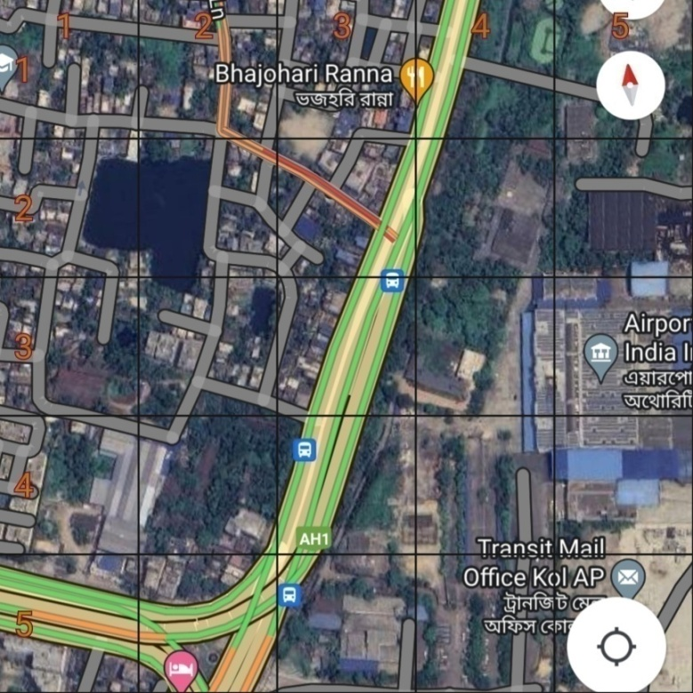

**Figure 3.1: Urban Region (Dum dum airport area, Kolkata, West Bengal, India)**

After the C program implementation the observations at different altitudes are as follows:

1. At altitude = 120m

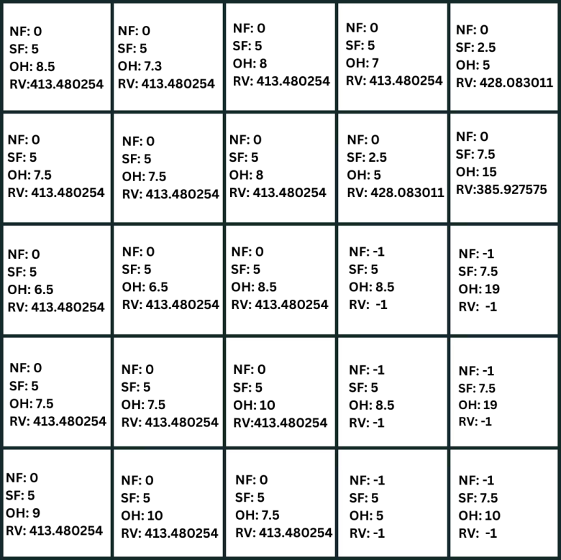

**Figure 3.1.a: Final risk value at altitude 120 m on Urban Region**

After the implementation at altitude 120m the final impact velocity and kinetic energy impact are respectively as52.250212 m/s and 5118.908796 J

1. At altitude = 60m

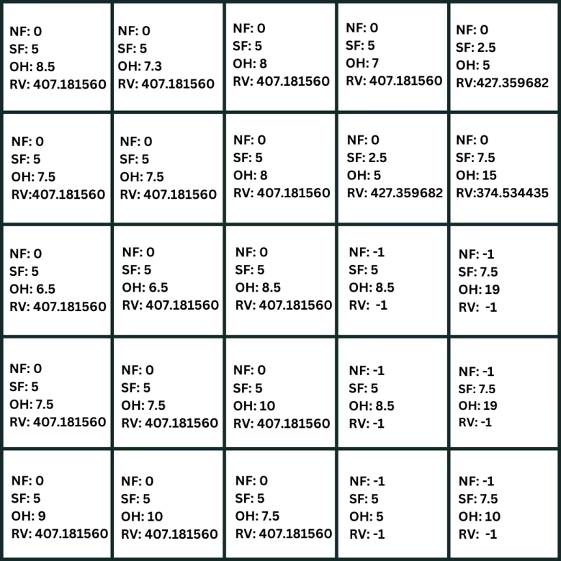

**Figure 3.1.b: Final risk value at altitude 60 m on Urban Region**

After the implementation at altitude 120m the final impact velocity and kinetic energy impact are respectively as39.421881 m/s and 2913.908796 J

1. At altitude = 25m

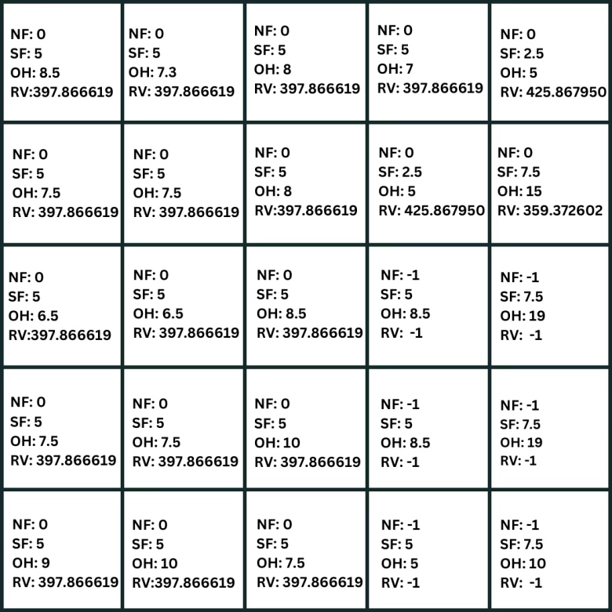

**Figure 3.1.c: Final risk value at altitude 25 m on Urban Region**

After the implementation at altitude 120m the final impact velocity and kinetic energy impact are respectively as29.463277 m/s and 1627.658796 J

**3.2 Sub Urban Region**

In this case Madhyamgram region of West Bengal is taken and then risk map of 5 x 5 matrixes are generated on that region.

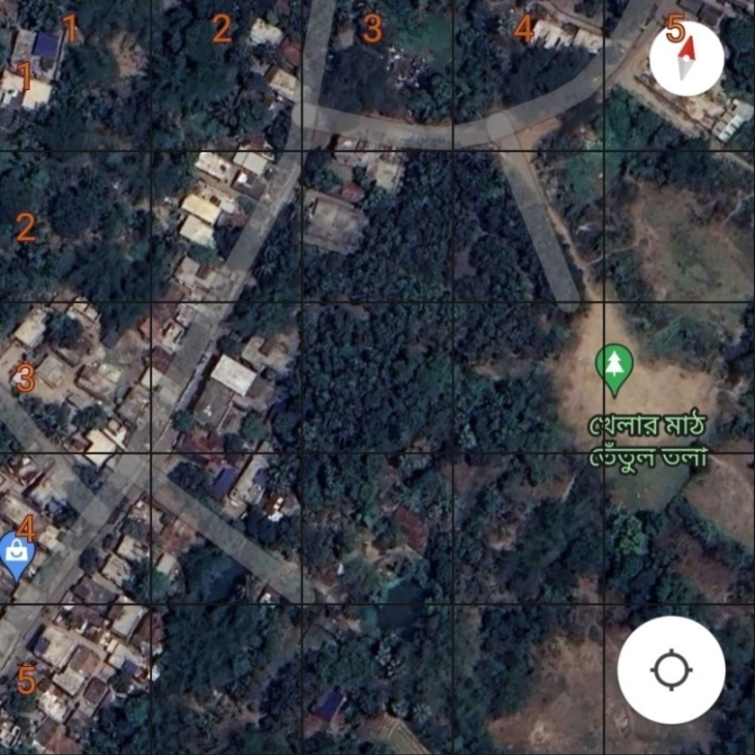

**Figure 3.2: Sub Urban Region (Madhyamgram area, West Bengal, India)**

After the C program implementation the observations at different altitudes are as follows:

1. At altitude = 120m

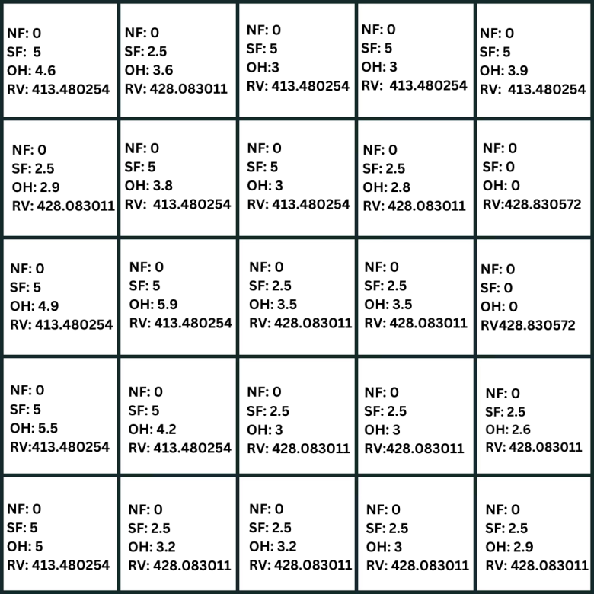

**Figure 3.2.a: Final risk value at altitude 120 m on Sub Urban Region**

After the implementation at altitude 120m the final impact velocity and kinetic energy impact are respectively as52.250212 m/s and 5118.908796 J

1. At altitude = 60m

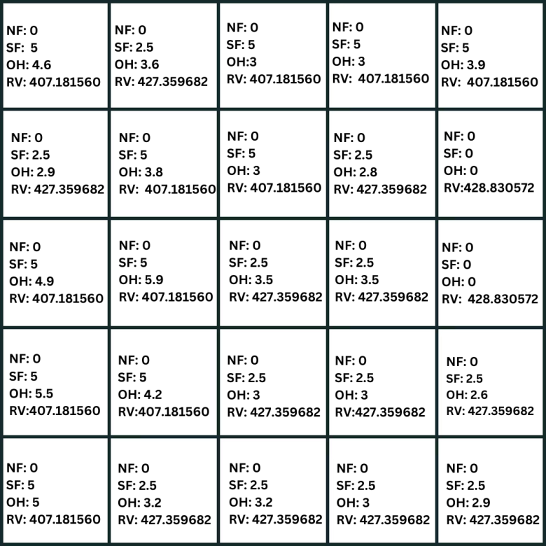

**Figure 3.2.c: Final risk value at altitude 60 m on Sub Urban Region**

After the implementation at altitude 120m the final impact velocity and kinetic energy impact are respectively as39.421881 m/s and 2913.908796 J

1. At altitude = 25m

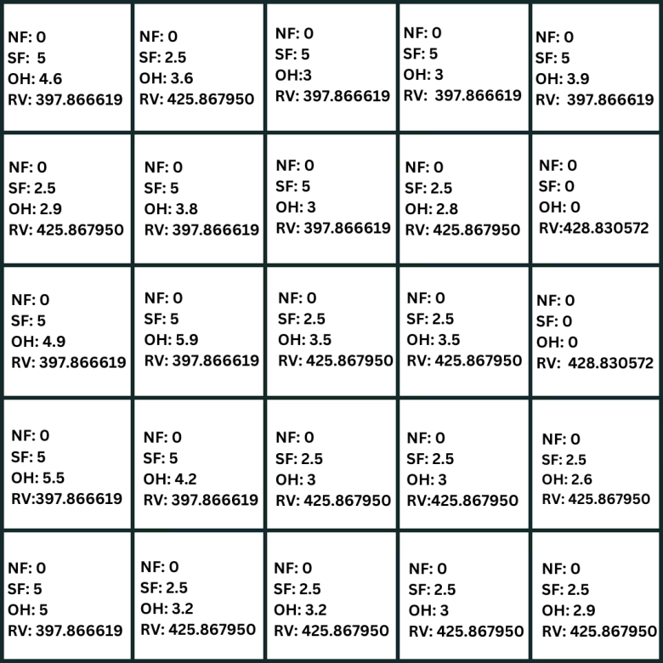

**Figure 3.2.c: Final risk value at altitude 25 m on Sub Urban Region**

After the implementation at altitude 120m the final impact velocity and kinetic energy impact are respectively as29.463277 m/s and 1627.658796 J

**3.3 Rural Region**

In this case Iswarpur region of West Bengal is taken and then risk map of 5 x 5 matrixes are generated on that region.

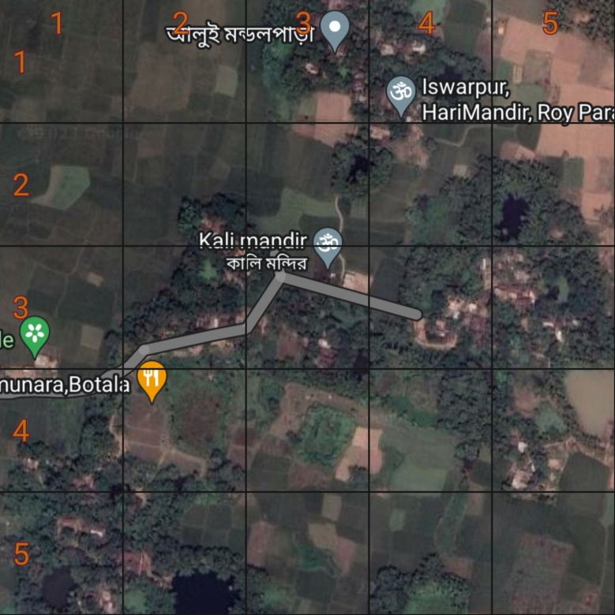

**Figure 3.3: Rural Region (Iswarpur area, West Bengal, India)**

After the C program implementation the observations at different altitudes are as follows:

1. At altitude = 120m

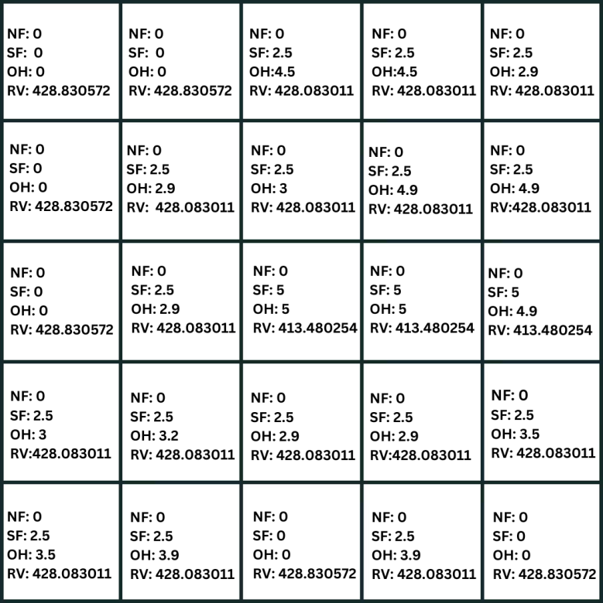

**Figure 3.3.a: Final risk value at altitude 120 m on Rural Region**

After the implementation at altitude 120m the final impact velocity and kinetic energy impact are respectively as52.250212 m/s and 5118.908796 J

1. At altitude = 60m

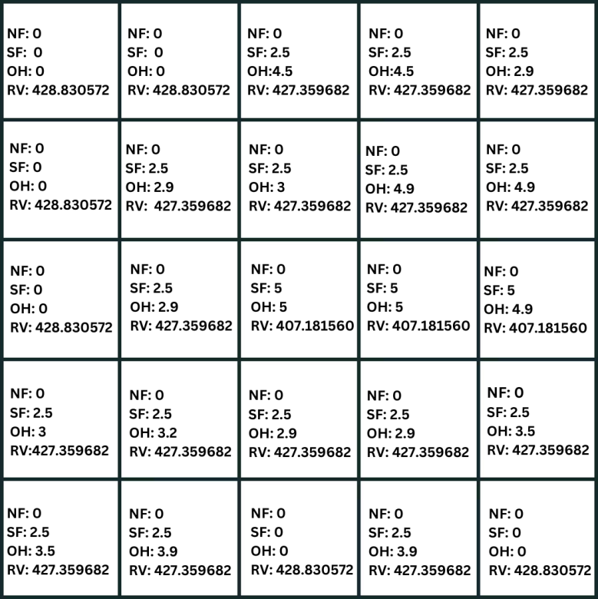

**Figure 3.3.b: Final risk value at altitude 60 m on Rural Region**

After the implementation at altitude 120m the final impact velocity and kinetic energy impact are respectively as39.421881 m/s and 2913.908796 J

1. At altitude = 25m

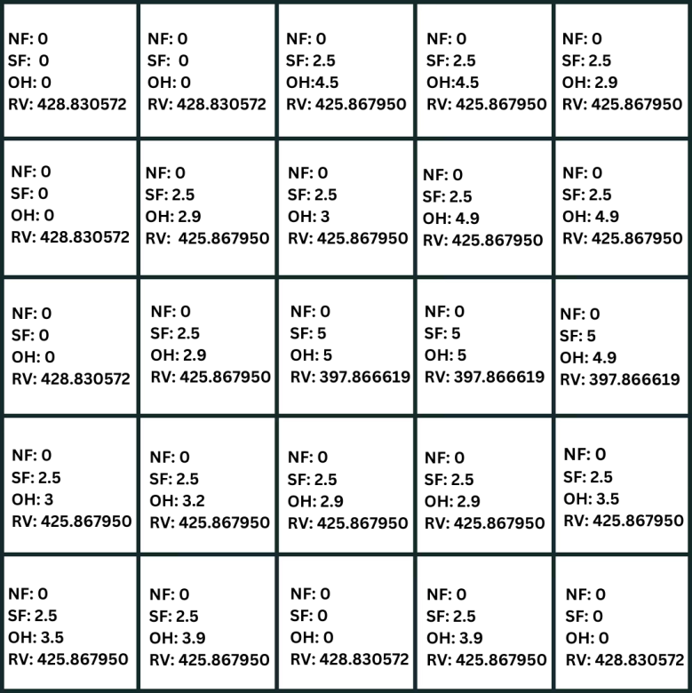

**Figure 3.3.c: Final risk value at altitude 25 m on Rural Region**

After the implementation at altitude 120m the final impact velocity and kinetic energy impact are respectively as29.463277 m/s and 1627.658796 J

**Chapter 4**

**4. Result**

Finally from all the data maximum, average and minimum risk of all the three regions are find out and on them graphical analysis is done which are given as follows.

**4.1 Graphical Analysis of Urban Region:**

|  |  |  |  |
| --- | --- | --- | --- |
| **Urban Region** | **120 m** | **60 m** | **25 m** |
| **Max** | 428.083011 | 427.359682 | 425.86795 |
| **Avg** | 413.567245 | 407.587303 | 398.788126 |
| **Min** | 385.927575 | 374.534435 | 359.372602 |

**Figure 4.1.a: Table of maximum, average and minimum values from risk map of urban region**

**Figure 4.1.b: Graphical Analysis of maximum, average and minimum risk value for urban region**

After the analysis it’s conclude that the risk value of any particular grid is totally depend upon the value of the sheltering factor. As sheltering factor quantifies the level of shelter to people on a particular area. So more the value of the sheltering factor less will be the impact and ultimately less will be the risk.

Even the risk value is also depending on the impact of the kinetic energy. Due to the change in altitude of the drone there is a change in the final impact velocity which ultimately changes in the impact of the kinetic energy. For this there is a change in the risk value at different altitude.

Final impact velocity (*vimp*) = *u= initial velocity of drone*

*h = altitude at which the drone will fly*

Kinetic Energy = *.m.(vimp)2* *m = mass of the drone*

In case of maximum risk of the urban region the sheltering factor is 2.5 which is very low for which the risk value is maximum. Whereas for the minimum risk the sheltering factor is 7.5.

When the sheltering factor is 0 or close to 0 then there is not a huge difference on the risk value on changing the altitude. For which in case of maximum risk on urban region there is not so much change on the risk value which is almost equal.

**4.2 Graphical Analysis of Sub Urban Region:**

|  |  |  |  |
| --- | --- | --- | --- |
| **Sub Urban** | **120 m** | **60 m** | **25 m** |
| **Max** | 428.830572 | 428.830572 | 428.830572 |
| **Avg** | 415.708279 | 409.91348 | 399.631151 |
| **Min** | 413.480254 | 407.18156 | 397.866619 |

**Figure 4.2.a: Table of maximum, average and minimum values from risk map of sub urban region**

**Figure 4.2.b: Graphical Analysis of maximum, average and minimum risk value for sub urban region**

In case of sub urban region for the maximum risk the sheltering factor is 0 and for the minimum risk the sheltering factor is 5. The sheltering factor 0 defines on that particular region there is no obstacles or any specific things are not present where a person can take shelter during malfunction of the drone.

As the sheltering factor increasing there is a change in the final risk value while changing in the altitude of the drone. But in case of sheltering factor 0 while changing the altitude of the drone there is no change on the final risk value of a particular section of the risk map.

**4.3 Graphical Analysis of Rural Region:**

|  |  |  |  |
| --- | --- | --- | --- |
| **Rural** | **120 m** | **60 m** | **25 m** |
| **Max** | 428.830572 | 428.830572 | 428.830572 |
| **Avg** | 426.510094 | 425.29132 | 423.218819 |
| **Min** | 413.480254 | 407.18156 | 397.866619 |

**Figure 4.3.a: Table of maximum, average and minimum values from risk map of rural region**

**Figure 4.3.b: Graphical Analysis of maximum, average and minimum risk value for rural region**

Similarly like sub urban region in case of rural region the maximum risk is at sheltering factor 0 and the minimum risk at sheltering factor 5. While changing in the altitude there is a change in minimum risk but not in the maximum risk on the particular risk map.

**4.4 Graphical Analysis of different regions at same altitude**

1. At altitude = 120m

|  |  |  |  |
| --- | --- | --- | --- |
| **120m** | **Urban Region** | **Sub Urban Region** | **Rural Region** |
| **Max** | 428.083011 | 428.830572 | 428.830572 |
| **Avg** | 413.567245 | 415.708279 | 426.510094 |
| **Min** | 385.927575 | 413.480254 | 413.480254 |

**Figure 4.4.1.a: Table of maximum, average and minimum values of three different at altitude 120m**

**Figure 4.4.1.b: Graphical Analysis of Risk Value vs Different Regions at a Same Altitude (120 m)**

1. At altitude = 60m

|  |  |  |  |
| --- | --- | --- | --- |
| **60m** | **Urban Region** | **Sub Urban Region** | **Rural Region** |
| **Max** | 427.359682 | 428.830572 | 428.830572 |
| **Avg** | 407.587303 | 409.91348 | 425.29132 |
| **Min** | 374.534435 | 407.18156 | 407.18156 |

**Figure 4.4.2.a: Table of maximum, average and minimum values of three different at altitude 60m**

**Figure 4.4.2.b: Graphical Analysis of Risk Value vs Different Regions at a Same Altitude (60 m)**

1. At altitude = 25m

|  |  |  |  |
| --- | --- | --- | --- |
| **25m** | **Urban Region** | **Sub Urban Region** | **Rural Region** |
| **Max** | 425.86795 | 428.830572 | 428.830572 |
| **Avg** | 398.788126 | 399.631151 | 423.218819 |
| **Min** | 359.372602 | 397.866619 | 397.866619 |

**Figure 4.4.3.a: Table of maximum, average and minimum values of three different at altitude 25m**

**Figure 4.4.3.b: Graphical Analysis of Risk Value vs Different Regions at a Same Altitude (25 m)**

**Chapter 5**

**5.1 Conclusion**

After the analysis of all the three regions i.e. urban, sub urban and rural it is conclude that the sheltering factor plays a major role while calculating the risk assessment. When the sheltering factor is 0 in any particular grid it means that there is no external space for any person to take the shelter means it is totally an open ground. That implies the maximum risk will be there where sheltering factor is 0. While increasing in the sheltering factor the risk value is also gradually decreasing which concludes that sheltering factor is inversely proportional to the risk value.

But one major scenario is came into picture that at minimum sheltering factor while changing on the altitude of the drone the risk value is almost equal. As it is a probabilistic approach it finally concludes that when the sheltering factor is 0 the risk value is same irrespective of the altitude. When the value of sheltering factor increases then there is also a change in the risk value at different altitude. While the major change on the risk value occurs only when initial velocity and the altitude of the drone changes simultaneously at a time.

Among the three different regions the least risk is on the urban region because of the maximum value of the sheltering factor whole over the risk map that is generated. And the more risk on the rural region due to minimum value of the sheltering factor whole over the risk map.

**5.2 Future Work**

In this project only static risk is considered to find the risk value for assessment of the risk after the crash of UAV. And in future the main focus will be on the dynamic risk. Finally the whole risk assessment will be done.

**References**

[1] [Stefano Primatesta](https://ieeexplore.ieee.org/author/37085528388); [Matteo Scanavino](https://ieeexplore.ieee.org/author/37086944872); [Giorgio Guglieri](https://ieeexplore.ieee.org/author/37728324100); [Alessandro Rizzo](https://ieeexplore.ieee.org/author/37270764200); A Risk-based Path Planning Strategy to Compute Optimum Risk Path for Unmanned Aircraft Systems over Populated Areas; [2020 International Conference on Unmanned Aircraft Systems (ICUAS)](https://ieeexplore.ieee.org/xpl/conhome/9210448/proceeding)

[2] [Francesco Betti Sorbelli](https://arxiv.org/search/cs?searchtype=author&query=Sorbelli%2C+F+B), [Punyasha Chatterjee](https://arxiv.org/search/cs?searchtype=author&query=Chatterjee%2C+P), [Federico Corò](https://arxiv.org/search/cs?searchtype=author&query=Cor%C3%B2%2C+F), [Lorenzo Palazzetti](https://arxiv.org/search/cs?searchtype=author&query=Palazzetti%2C+L), [Cristina M. Pinotti](https://arxiv.org/search/cs?searchtype=author&query=Pinotti%2C+C+M); A Novel Multi-Layer Framework for BVLoS Drone Operation: A Preliminary Study; Conference paper 2023; https://arxiv.org/abs/2301.05835

[3] [Amrita Chatterjee](https://ieeexplore.ieee.org/author/37088378373); [Hassan Reza](https://ieeexplore.ieee.org/author/37281866800); Path Planning Algorithm to Enable Low Altitude Delivery Drones at the City Scale; [2019 International Conference on Computational Science and Computational Intelligence (CSCI)](https://ieeexplore.ieee.org/xpl/conhome/9052554/proceeding)

[4] [Pei-Chi Shao](https://sciprofiles.com/profile/1152544); Risk Assessment for UAS Logistic Delivery under UAS Traffic Management Environment; Aerospace 2020, 7(10), 140; <https://doi.org/10.3390/aerospace7100140>

[5] [Markus Ortlieb](https://ieeexplore.ieee.org/author/37088557296); [Florian-Michael Adolf](https://ieeexplore.ieee.org/author/37946010000); Rule-Based Path Planning for Unmanned Aerial Vehicles in Non-Segregated Air Space over Congested Areas; 11-15 October [2020 AIAA/IEEE 39th Digital Avionics Systems Conference (DASC)](https://ieeexplore.ieee.org/xpl/conhome/9256401/proceeding)

[6] [Lorenzo Becce](https://ieeexplore.ieee.org/author/37088915487); [Nicoletta Bloise](https://ieeexplore.ieee.org/author/37086456077); [Giorgio Guglieri](https://ieeexplore.ieee.org/author/37728324100); Optimal Path Planning for Autonomous Spraying UAS framework in Precision Agriculture; 15-18 June 2021 [International Conference on Unmanned Aircraft Systems (ICUAS)](https://ieeexplore.ieee.org/xpl/conhome/9476247/proceeding)

[7] [Elena Politi](https://ieeexplore.ieee.org/author/37088377131); [Iraklis Varlamis](https://ieeexplore.ieee.org/author/37540823900); [Konstantinos Tserpes](https://ieeexplore.ieee.org/author/37565808800); [Morten Larsen](https://ieeexplore.ieee.org/author/37088992134); [George Dimitrakopoulos](https://ieeexplore.ieee.org/author/37411162400); The future of safe BVLOS drone operations with respect to system and service engineering; 15-18 August 2022 [IEEE International Conference on Service-Oriented System Engineering (SOSE)](https://ieeexplore.ieee.org/xpl/conhome/9912462/proceeding)

[8] [Jurjen van der Sluijs](https://cdnsciencepub.com/doi/abs/10.1139/dsa-2023-0012#con1) [jurjen_vandersluijs@gov.nt.ca](mailto:jurjen_vandersluijs@gov.nt.ca), [Eyal Saiet](https://cdnsciencepub.com/doi/abs/10.1139/dsa-2023-0012#con2), [Carolyn Bakelaar](https://cdnsciencepub.com/doi/abs/10.1139/dsa-2023-0012#con3), [Andrew Wentworth](https://cdnsciencepub.com/doi/abs/10.1139/dsa-2023-0012#con4), [Robert Fraser](https://cdnsciencepub.com/doi/abs/10.1139/dsa-2023-0012#con5), and [Steven Kokelj](https://cdnsciencepub.com/doi/abs/10.1139/dsa-2023-0012#con6); Beyond visual-line-of-sight (BVLOS) drone operations for environmental and infrastructure monitoring: a case study in northwestern Canada; Drone Systems and Applications;11 August 2023;<https://doi.org/10.1139/dsa-2023-0012>

[9] [Jan Moros Esteban](https://arxiv.org/search/cs?searchtype=author&query=Esteban%2C+J+M), [Jaap van de Loosdrecht](https://arxiv.org/search/cs?searchtype=author&query=van+de+Loosdrecht%2C+J), [Maya Aghaei](https://arxiv.org/search/cs?searchtype=author&query=Aghaei%2C+M); Obstacle Detection for BVLOS Drones; Submitted on 21 Jun 2021 ([v1](https://arxiv.org/abs/2106.11098v1)), last revised 22 Jun 2021; https://arxiv.org/abs/2106.11098

**Appendix**

The C code is given as follows:

#include<stdio.h>

#include<math.h>

double shelter[10][10], beta, alpha, E_imp,v_imp;

int main()

{

int n, i, j, no_fly[10][10];

double event, impact, obstacle[10][10], fatality[10][10], casualty[10][10], risk[10][10], h_threshold,u,m,g;

double p_impact();

double p_fatality(int, int);

//Initialization.....

printf("Generating Risk Map (N X N)");

printf("\n\t\tEnter N (<10):");

scanf("%d", &n);

printf("\n\t\tEnter values for no fly zone....\n\t\t(-1:flight not allowed; 0:flight allowed)");

for (i=1; i<=n; i++)

{

for (j=1; j<=n; j++)

{

printf("\n\t\tLocation (%d, %d):", i, j);

scanf("%d", &no_fly[i][j]);

}

}

printf("\n\t\tEnter heights for obstacles....");

for (i=1; i<=n; i++)

{

for (j=1; j<=n; j++)

{

printf("\n\t\tLocation (%d, %d):", i, j);

scanf("%lf", &obstacle[i][j]);

}

}

printf("\n\t\tEnter threshold height:");

scanf("%lf", &h_threshold);

printf("\n\t\tEnter sheltering factors....\n\t\t(0:No obstacles, 2.5:sparse tree, 5:vehicles & low buildings, 7.5:high buildings, 10:industrial building)");

for (i=1; i<=n; i++)

{

for (j=1; j<=n; j++)

{

printf("\n\t\tLocation (%d, %d):", i, j);

scanf("%lf", &shelter[i][j]);

}

}

//v_imp value calculation

printf("\n\t\tEnter values of u (19.4444m/s): ");

scanf("%lf", &u);

printf("\n\t\tEnter values of g (9.8m/s^2): ");

scanf("%lf", &g);

v_imp=sqrt((u*u)+(2*g*h_threshold));

printf("The value of final impact velocity is: %lf\n", v_imp);

//E_imp calculation

printf("\n\t\tEnter the mass of uav(3.75kg): ");

scanf("%lf", &m);

E_imp=0.5*m*v_imp*v_imp;

printf("The value of kinetic energy of impact E_imp: %lf\n", E_imp);

//Risk map generation......

printf("\n\t\tEnter event(crash) probability: ");

scanf("%lf", &event);

printf("Calculatig P_impact....");

impact=p_impact();

printf("\n\t\tP_impact: %lf", impact);

printf("\n\t\tCalculatig P_fatality....");

printf("\n\t\tEnter value of impact energy beta (34J):");

scanf("%lf", &beta);

printf("\n\t\tEnter value of impact energy alpha (100KJ):");

scanf("%lf", &alpha);

for (i=1; i<=n; i++)

{

for (j=1; j<=n; j++)

{

fatality[i][j]=p_fatality(i, j);

printf("\n\t\tP_fatality(%d,%d):%lf",i,j,fatality[i][j]);

casualty[i][j]=event*impact*p_fatality(i, j);

if (no_fly[i][j]==-1 || obstacle[i][j]>=h_threshold)

risk[i][j]=-1;

else

risk[i][j]=casualty[i][j];

printf("\n\t\tRisk (%d, %d): %lf", i, j, risk[i][j]);

}

}

printf("\n\t\tRisk map generation completed.");

}

double p_impact()

{

double impact, population, r_p, r_uav, h_p, radian, a_exp, pi=3.14;

printf("\n\t\tEnter population density (6900 people/km^2):");

scanf("%lf", &population);

printf("Enter average radius of a person(0.248m):");

scanf("%lf", &r_p);

printf("\n\t\tEnter radius of UAV(0.88m):");

scanf("%lf", &r_uav);

printf("\n\t\tEnter average height of a person(1.587m):");

scanf("%lf", &h_p);

printf("Enter impact angle(in radians) [0.401426]:");

scanf("%lf", &radian);

a_exp=2*(r_p+r_uav)*h_p/tan(radian)+ pi*pow((r_uav+r_p),2);

impact=population*a_exp;

return(impact);

}

double p_fatality(int x, int y)

{

double fatality, k, temp;

temp=pow((beta/E_imp),(3/shelter[x][y]));

if (temp<1) k=temp;

else k=1;

fatality=(1-k)/(1-2*k+sqrt(alpha/beta)*pow(beta/E_imp,3/shelter[x][y]));

return(fatality);

}